


IVF Project
Graduation Project Documentation
Data Engineering Track
ONL3_AIS5_G1

December 2025

IVF Project

BY

Rawan Arafa Abdelmaksoud Fatma Mohamed
Dina Nabil Ahmed Gehad Abbas Taha
Menna Abdelnasser Galal Sherri Sami Morris
Tasneem Tarek Abdulrahim

Supervisor
Eng/ Ahmed Hekal

Project Planning & Management
- Project Proposal
  - Overview:
Elysium is a data-driven clinical decision-support system designed for In-Vitro Fertilization (IVF) clinics. It transforms historical and operational fertility clinic data into structured, meaningful insights to assist medical staff and administrators in making evidence-based clinical decisions.

The system consolidates clinical records, hormonal and laboratory results, and IVF cycle data into a unified structured database. Through a well-defined data engineering pipeline, it enables efficient extraction, transformation, and loading (ELT) of data, ensuring quality and consistency.

The primary deliverable is a web-based administrative platform that provides IVF success probability estimates, periodic performance analytics, and data-driven recommendations, all while maintaining patient data confidentiality and regulatory compliance.

  - Objectives:
The main objectives of the Elysium system are to:
- Develop a predictive model to estimate IVF cycle success probability based on key clinical and laboratory parameters.
- Design and implement a robust data engineering pipeline (ingest → clean → stage → warehouse) to maintain structured, analysis-ready data.
- Create an interactive dashboard for administrators and clinicians to:
  - Monitor IVF outcomes.
  - Analyze trends and influencing factors.
  - Access visualized data insights easily.
- Provide automated performance reports that summarize clinic statistics and model predictions.
- Enable a continuous learning mechanism that updates the predictive model with new outcomes to enhance accuracy and reliability.

  - Scope:
    - Included (within MVP and core features):
- Ingestion of structured data sources, including clinical records, lab results, and historical IVF cycle data.
- Data cleaning and normalization of hormonal and clinical measurements.
- Implementation of automated ELT pipelines and task scheduling using Apache Airflow.
- Development of an admin-facing web application for:
  - Viewing patient-level and aggregate data.
  - Filtering records and generating visual analytics.
  - Exporting performance reports.
    - Excluded (out of scope for MVP / planned future work):
- Image-based embryo selection or quality assessment using computer vision.
- Applying data governance and privacy measures, including:
  - Anonymization of sensitive information.
- Real-time integration with external EMR systems (planned for later using HL7/FHIR standards).
- Mobile application for patients (only web interface for administrators in MVP).
- Genetic data integration and multi-site scalability (future enhancement phases).
- Training and evaluation of baseline machine learning models (e.g., Logistic Regression, Random Forest, XGBoost).
- Role-based access control (admin/user).
- Basic audit logging for system transparency.

- Project Timeline
  - Phase 1: Data Engineering & Infrastructure Setup (Weeks 1–8)
- Goal: Build a secure and reliable data foundation for the system and analysis.
- Tasks & Milestones:
  - Identify data sources (patients, labs), define access roles, and set up AWS cloud structure.
  - Build a data ingestion pipeline (Airflow + API integration) with monitoring and logging.
  - Perform data cleaning and transformation using Pandas and apply data validation
  - Create Data Warehouse (Star Schema), test data accuracy and performance, and initiate project documentation in the /Documentation folder.
- Milestone: Functional and secure data pipeline with validated warehouse and initial documentation.
  - Phase 2: MVP — Doctor Web App & Dashboard (Weeks 8–12)
- Goal: Develop and connect the doctor dashboard with live data flow.
- Tasks & Milestones:
- Design and implement UI/UX (soft pastel theme, intuitive layout).
- Connect Flask backend with database.
- Build dashboard components (Patients, IVF Cycles, Reports, and Settings).
- Integrate analytics charts (success rate, cycle stages, etc.) and conduct system testing.
- Milestone: MVP live with secure doctor access and a fully functional dashboard.

  - Phase 3: Finalization & Presentation (Weeks 13–14)
- Goal: Deliver final product, documentation, and demo presentation.
- Tasks & Milestones:
- Review and finalize all documentation, including risk assessment and system diagrams.
- Prepare final presentation, and project submission.
- Milestone: Final system delivered with complete documentation and presentation.

  - Phase 3: System Enhancement & Expansion (Future Plan)
- Goal: Add additional user roles and extend system functionality.
- Tasks & Milestones:
- Add Clinic Administrator role (manage doctors, view reports).
- Add Lab Staff role (input lab test results and sync with dashboard).
- Add Patient role (view reports and receive notifications).
- Implement notification system, finalize role-based permissions, and update documentation.
- Milestone: Multi-role system completed, fully tested, and documented.

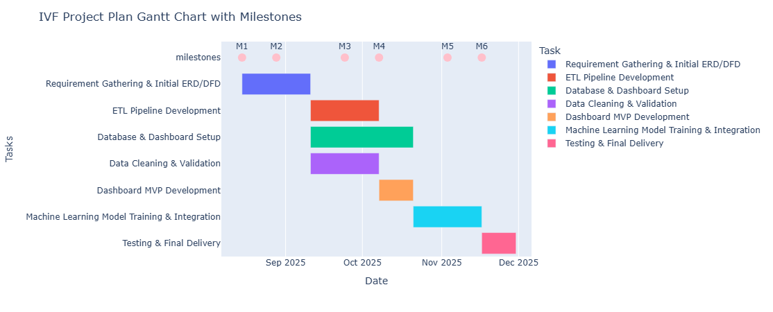

- Task Assignment & Roles
To ensure balanced workload distribution and effective collaboration, each team member was assigned both managerial and technical responsibilities according to her expertise. The managerial roles cover planning, documentation, coordination, and reporting, while the technical roles encompass the system’s full development lifecycle, from data acquisition and transformation to design, integration, and deployment.
Member | Managerial Responsibilities | Technical Responsibilities (Tools & Technologies)
Rawan (Team Leader) | • Prepare Project Plan (timeline, milestones, Gantt chart).  • Handle Task Assignment & Roles documentation.  • Write Risk Assessment & Mitigation Plan.  • Oversee team coordination and ensure milestone delivery.  • Approve final documentation and integration consistency. | - ETL pipeline development (extract → transform → load).  - Data cleaning, validation & fixing scripts.  - Mapping raw IVF database tables to star schema dimensions & fact tables.  - Handling data quality issues (missing values, mismatches, formats).  - Automating transformations & preparing data for dashboards
Menna | • Write Project Proposal (overview, objectives, scope).  • Define Technology Stack and architecture style.  • Document Software Architecture and integration flow. | - Co-developing ETL workflows with Rawan.  - Writing SQL transformation scripts for the warehouse.  - Implementing validation rules & exception reports.  - Supporting the star schema population and testing data correctness.
Tasneem | • Conduct Stakeholder Analysis and gather functional requirements.  • Prepare Use Cases and User Stories. | • Develop data extraction and transformation scripts (Python + Pandas).  • Create dbt models for transformations and aggregations.  • Maintain data validation and version control.  • Support Airflow ETL validation.
Dina | • Document System Workflow Diagrams (DFD, sequence, activity).  • Design and implement Database Schema (SQL).  • Create ERD and Class Diagrams.  • Review and optimize data models for efficiency.  • Assist in system testing and validation. | • Set up AWS RDS (PostgreSQL/MySQL).  • Connect Flask ORM models to the database.  • Implement database indexing, stored procedures, and triggers for performance.  • Support ETL validation and integration with backend.  • Assist in data migration and backup processes.
Fatma | • Review UI consistency and assist in UI testing.  • Coordinate between frontend and backend integration. | - Setting up Airflow pipelines for automation.  - JSON → database ingestion workflow.  - Scheduling ETL jobs and monitoring pipeline performance.  - Ensuring reproducibility and pipeline reliability.
Sherry | • Define UI/UX Guidelines (colors, layout, typography).  • Present the user interface during the final presentation. | - Backend development (Flask / Python).  - Creating API endpoints to fetch IVF data for the website.  - Integrating frontend with the database and warehouse.  - Handling routing, authentication (if any), and server logic.
Jihad | • Define KPIs and document system performance metrics.  • Review and ensure documentation consistency. | - Frontend development of the project website (HTML/CSS/JS).  - Designing pages for patients, doctors, cycles, and analytics.  - Implementing responsive layouts & consistent UI theme.

- Risk Assessment & Mitigation Plan
  - Phase 1: Data Engineering & Infrastructure Setup
Risk | Description | Mitigation Strategy
Data Integration | Issues connecting data sources (patient data, lab results). | Test early with mock data; use Airflow to automate and monitor pipelines.
Data Quality | Inaccurate or missing data during extraction or cleaning. | Use validation tools (Great Expectations); log all transformations.
Dependency | External tools (Airflow) may fail or face downtime. | Keep local backups, document setup, and enable service alerts.
Performance | Slow processing as data size increases. | Optimize queries and storage, and monitor regularly.

  - Phase 2: Doctor Web App & Dashboard
Risk | Description | Mitigation Strategy
Functional Issues | Some features (reports) may not work as intended. | Test features step by step; gather feedback from doctors.
UI/UX | The dashboard may not be user-friendly or clear. | Get user feedback and adjust the design before launch.
Data Entry Errors | Doctors might enter incorrect or incomplete data. | Add form validation; use error messages.
Integration | Dashboard analytics are not updating correctly. | Check Power BI connections and schedule regular data refresh.

- Key Performance Indicators (KPIs)
KPI | Description | Target
System Uptime | The percentage of time the system is available and running without interruption. | ≥ 99%
Page & Dashboard Response Time | Average time to load pages and dashboard views. | ≤ 3seconds

  - Data Pipeline Quality
KPI | Description | Target
ETL  Success  Rate | Percentage of successful data extraction, transformation, and loading operations. | ≥ 98%
Data Accuracy | The consistency and correctness of data between the source and the warehouse. | ≥ 97%

  - User Engagement
KPI | Description | Target
Active Doctor Usage | Percentage of registered doctors who use the platform weekly. | ≥ 80%
Usability Rating | Average score from user feedback on clarity and ease of use. | ≥ 8/10
  - Data Warehouse Performance
KPI | Description | Target
Query Execution Time | Average time to execute analytical queries on AWS. | ≤ 5 seconds
Redundant Data | Percentage of duplicated data after cleaning and validation. | ≤ 10%

  - Security & Reliability

KPI | Description | Target
Unauthorized Access | Number of unauthorized access attempts during testing. | 0

  - Project Delivery
KPI | Description | Target
Milestone Completion Rate | The percentage of project milestones completed within schedule (±1 week). | 100%

Requirements Gathering
- Stakeholders Analysis
Stakeholder | Role / Description | Needs & Expectations
Doctors / Fertility Specialists  (mvp) | Primary users are responsible for entering patient data, managing cycles, and viewing analytics. | - Easy data entry and retrieval.- Accurate, organized patient history.- Insightful dashboard to support decisions.- Secure access to sensitive information.
Patients | End-users who can view their treatment history and receive recommendations. | - Simple, accessible interface.- Privacy and data protection.- Transparent treatment tracking.- Personalized feedback and reminders.
Clinic Administrators | Manage system operations, user permissions, and data quality. | - Smooth workflow between staff.- Role-based access control.- Data validation and monitoring tools.- Comprehensive reporting features.
Data Engineers / Developers  (mvp) | Technical team maintaining the data pipeline, database, and web app. | - Clear architecture and documentation.- Automated and reliable ETL processes.- Monitoring and alerting mechanisms.- Scalable cloud infrastructure.
Management / Investors  (mvp) | Oversee the project’s success and return on investment. | - Performance metrics and KPIs.- Clear visual insights on outcomes.- Scalability and market potential.- Compliance with healthcare data regulations.
Laboratory Staff | Input or verify hormonal and test results in the system. | - Easy upload and validation process.- Consistency between lab data and patient records.- Quick correction of errors.

- Functional Requirements
  - Phase 1: Data Engineering & Infrastructure Setup
- Data Collection & Sources
  - Import patient data from clinics (EMR systems), lab results, historical IVF cycles, and manual entries.
  - Support future addition of wearable device data.
  - Standardize data formats (CSV, SQL, API) and maintain a Data Dictionary.
- Data Ingestion
  - Automate extraction from databases and APIs using Python and Airflow.
  - Schedule and monitor ETL tasks to ensure timely ingestion.
- Data Cleaning & Transformation
  - Remove nulls, duplicates, and inconsistent values.
  - Standardize hormonal units and categorize ages (bins).
  - Apply One-Hot Encoding and compute derived features (BMI, hormone ratios, cycle success rates).
  - Store processed data in a staging area ready for analysis.
- Data Warehouse Design
  - Maintain structured storage using a star schema: Fact_IVF_Cycles, Dim_Patient, Dim_Hormones, Dim_Embryos, Dim_Treatment.
  - Support fast analytics and querying for dashboards and ML models.
- Data Validation & Monitoring
  - Validate data quality using custom script.
  - Maintain ETL logs.
  - Send alerts on pipeline failures.
  - Phase 2: MVP — Web Application & Dashboard
- Web Application Features
  - Patient data input form.
  - Doctor dashboard showing full patient history and recommendations.
  - Responsive UI.
  - Connect frontend (HTML/CSS/JS) to backend (Flask API).
- Dashboard & Visualization
  - Display IVF success rates by age, protocol, hormones, and other key factors.
  - Interactive monthly/yearly averages and heatmaps to identify patterns.
  - Connect Power BI to the clean database.
  - Embed the dashboard into the web app.
  - Future Plan: Predictive Modeling & Continuous Learning
- Machine Learning Pipeline
  - Train, validate, and deploy predictive models (Logistic Regression, Random Forest, XGBoost).
  - Use MLflow to save models and track experiments.
  - Provide API endpoints for real-time predictions integrated into the web app.
- Continuous Learning
  - Retrain models periodically using Airflow.
  - Include new outcomes for continuous feedback and monitor model drift.
- Mobile Integration
  - Allow patients to submit data via mobile apps (React Native / Flutter).
  - Send reminders for tests, medications, and appointments.
- EMR & External Integration
  - Sync with EMR systems using HL7/FHIR standards.
  - Support automated data updates from clinics.
- Advanced Features
  - Integrate genetic and wearable data for advanced analysis.
  - Support multilingual interfaces (Arabic, English, French).
Overall Functional Goals:
- Secure, clean, and structured data pipeline.
- Interactive dashboards for doctors and patients.
- Predictive AI model with continuous learning.

- Non-Functional Requirements
  - Performance
- ETL pipelines must efficiently process large volumes of IVF-related data.
- Dashboards should load within 2–3 seconds for standard analytical queries.
  - Usability
- Provide an intuitive and responsive web-based dashboard for seamless interaction with visual reports and analytics.
- Include input validation features in all forms.
  - Reliability & Availability
- Maintain a target uptime of 99%.
- Implement automated monitoring and alerting for ETL pipeline or model failures.
- Maintain continuous logging and audit trails for compliance and debugging.
  - Maintainability
- Adopt a modular code architecture for ETL, ML, and dashboard components.
- Provide comprehensive documentation of data schemas and APIs.
- Include automated testing for critical functionalities.

System Analysis & Design

- Problem Statement & Objectives
  - Software Architecture
The IVF Management System is designed using the Model–View–Controller (MVC) architectural pattern, which divides the system into three main components to ensure scalability, maintainability, and a clear separation of concerns.

- Model Layer
  - Responsible for managing the system’s data and database interactions.
  - Stores information related to patients, IVF cycles, treatment details, and reports.
  - Handles all operations related to data storage, retrieval, and updates.

- Controller Layer
  - Acts as the communication bridge between the Model and View layers.
  - Receives input from the doctor (the current system user), validates it, and triggers the required logic.
  - Fetches or updates data in the Model and sends the processed results back to the View for presentation.
  - Ensures that data entered (e.g., patient details, IVF cycle updates) follows medical record standards and system validation rules.

- View Layer (Presentation Layer)
  - Provides the graphical user interface (GUI) through which the doctor interacts with the system.
  - Designed according to a clean, soft, and medical-friendly UI/UX concept, using:
  - Color palette: blush pink, lavender, light teal, and white.
  - Typography: rounded, modern sans-serif fonts (Poppins / Nunito).
  - Mood: calm, caring, and trustworthy.
  - Ensures a responsive layout with a sidebar for navigation and dashboard visualization tools.
  - Currently supports a single user role — Doctor — who manages patient registration, IVF cycles, and reports.

System Component Interaction Overview
  - The Doctor (User) interacts with the View through forms and dashboards.
  - The Controller processes these requests (e.g., “Add New Patient”, “Update Cycle Details”), applies validation rules, and communicates with the Model.
  - The Model updates or retrieves the necessary data from the database.
  - The Controller sends the results back to the View, which displays updated charts, patient details, or reports.
  - This architecture ensures smooth data flow, secure input handling, and a clear modular structure that supports future scalability — such as adding more user roles (e.g., Admin, Lab Staff) or new analytical features.

- Database Design & Data Modeling
  - ER Diagram (Entity-Relationship Diagram)
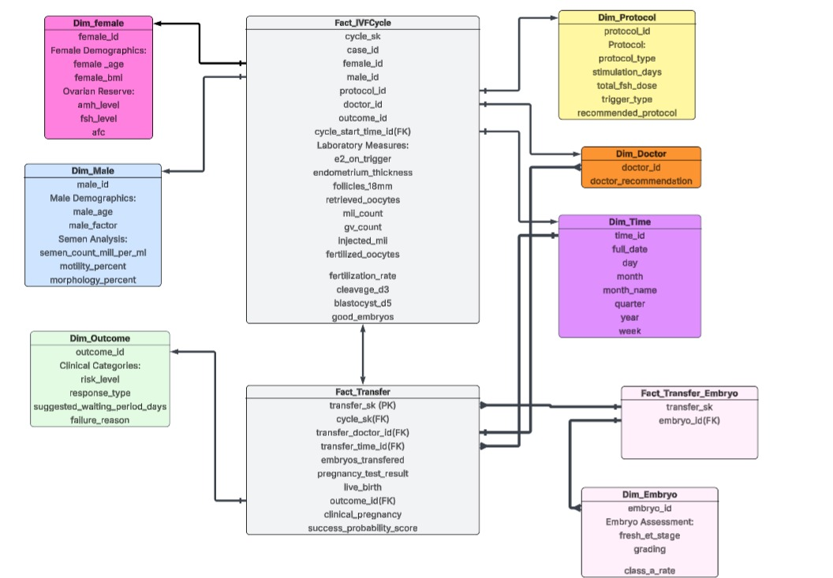

- Data Flow & System Behavior
  - DFD (Data Flow Diagram)
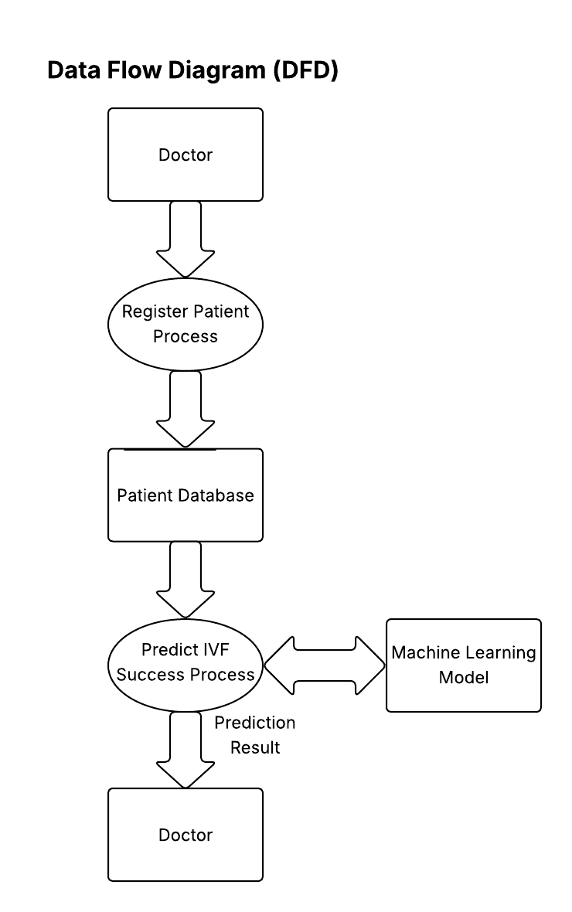

  - Sequence Diagrams

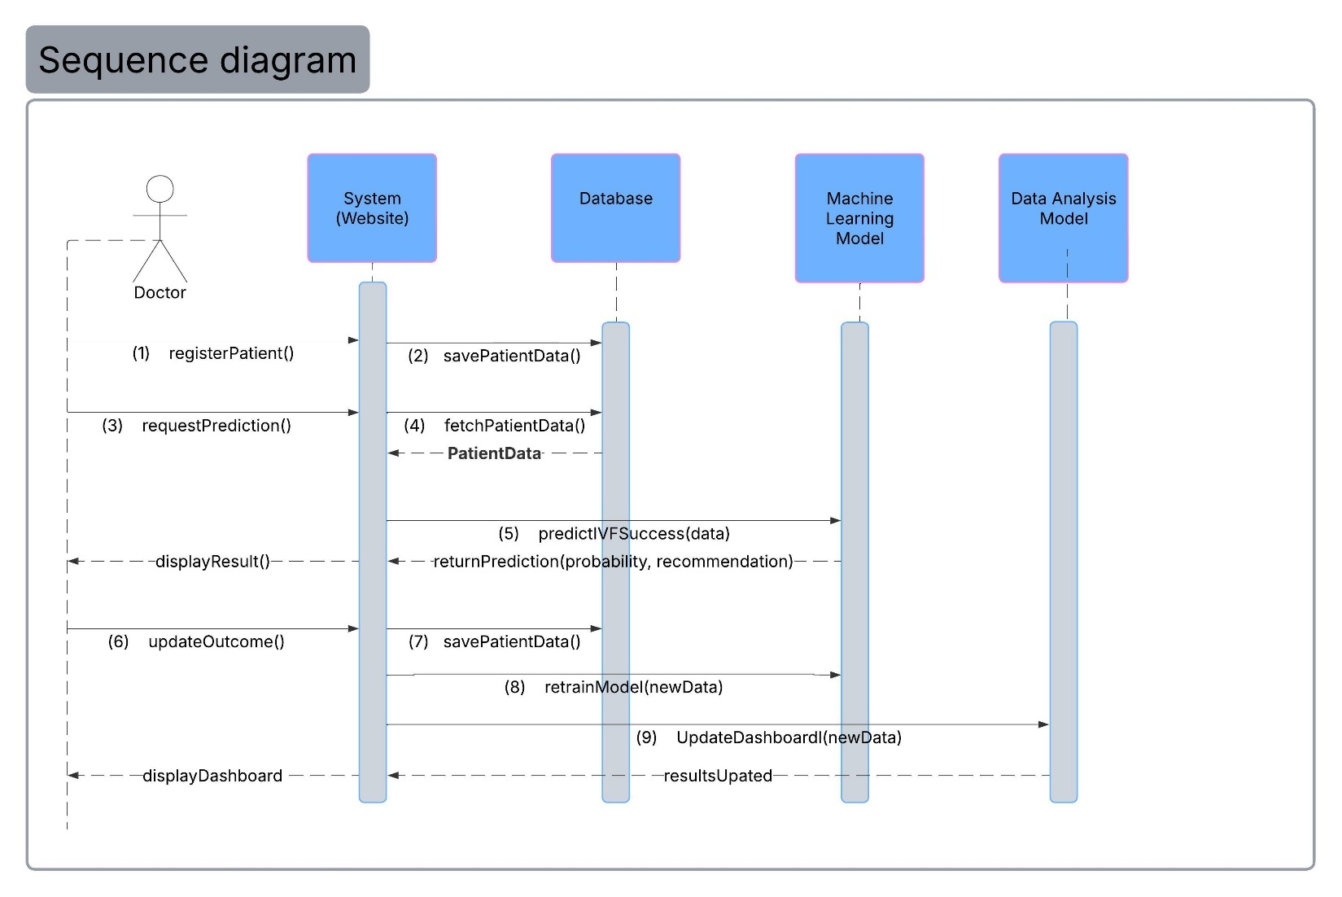

  - Activity Diagram
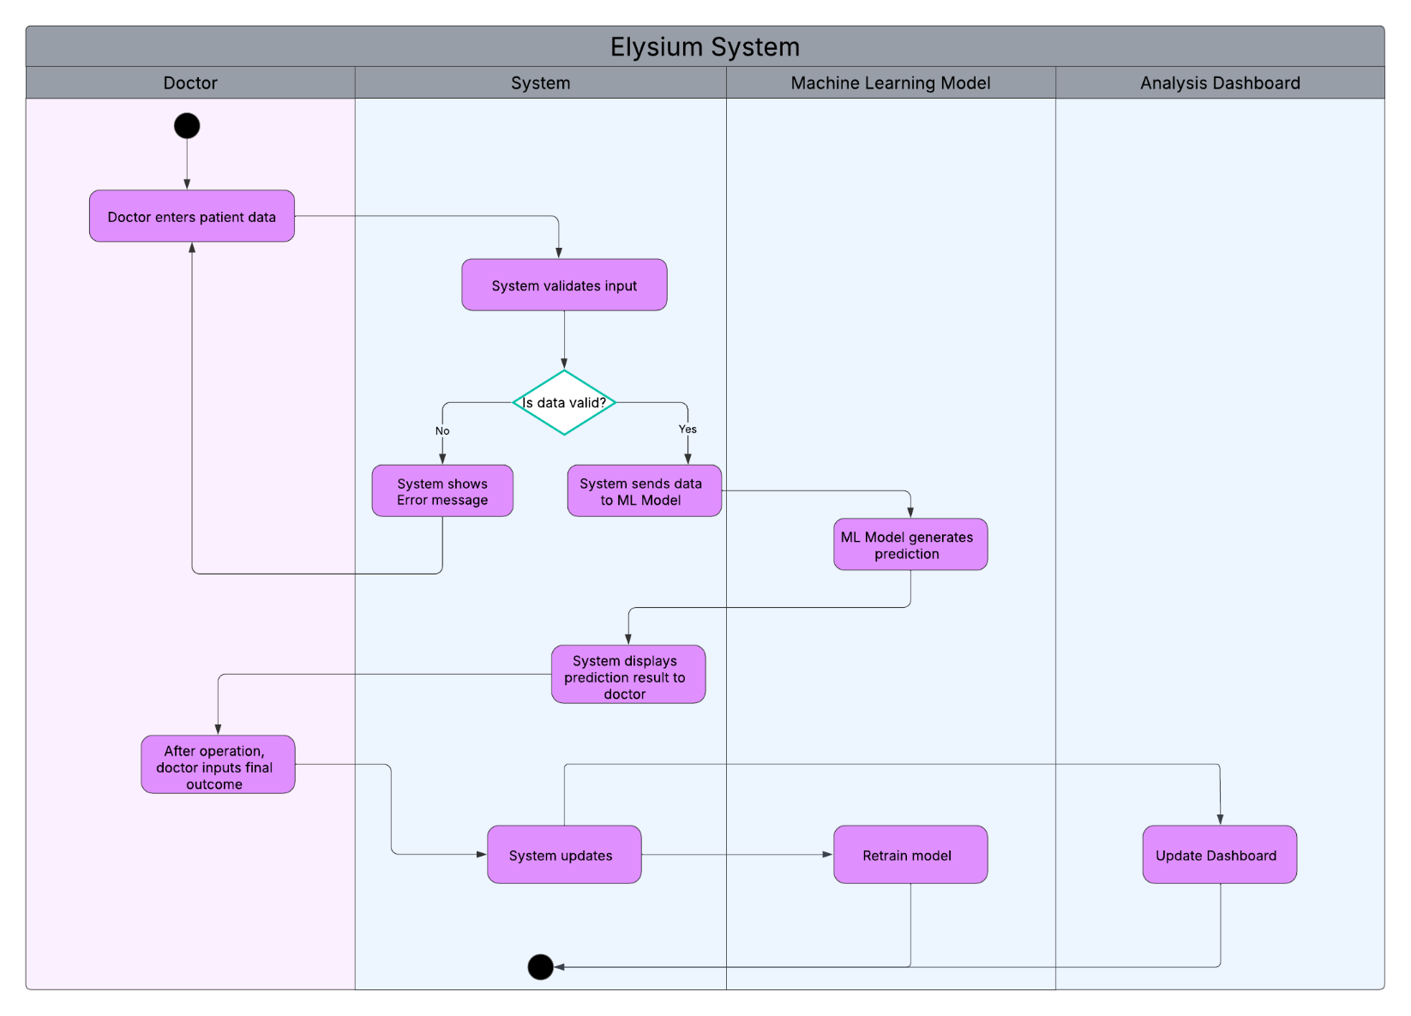

  - Class Diagram

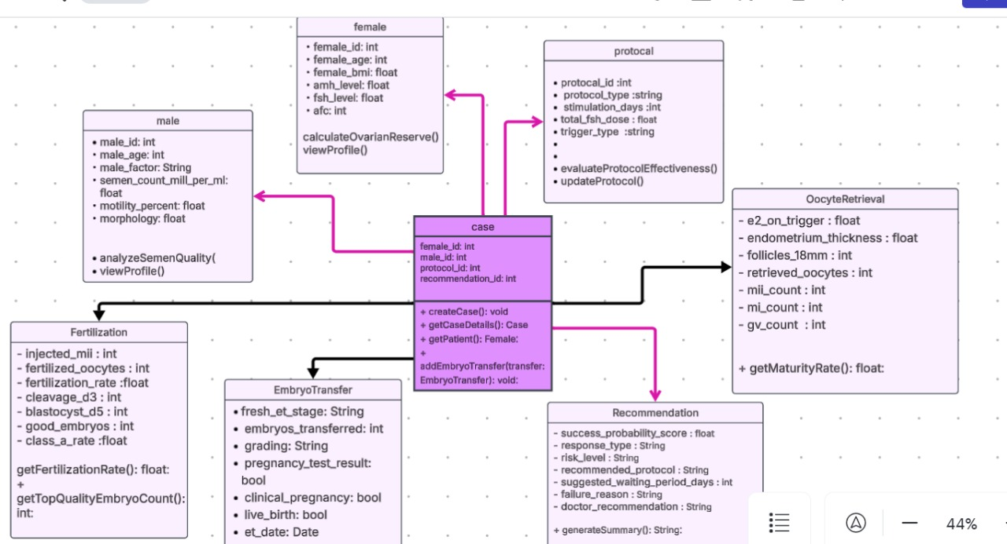

- UI/UX Design & Prototyping

- Wireframes & Mockups
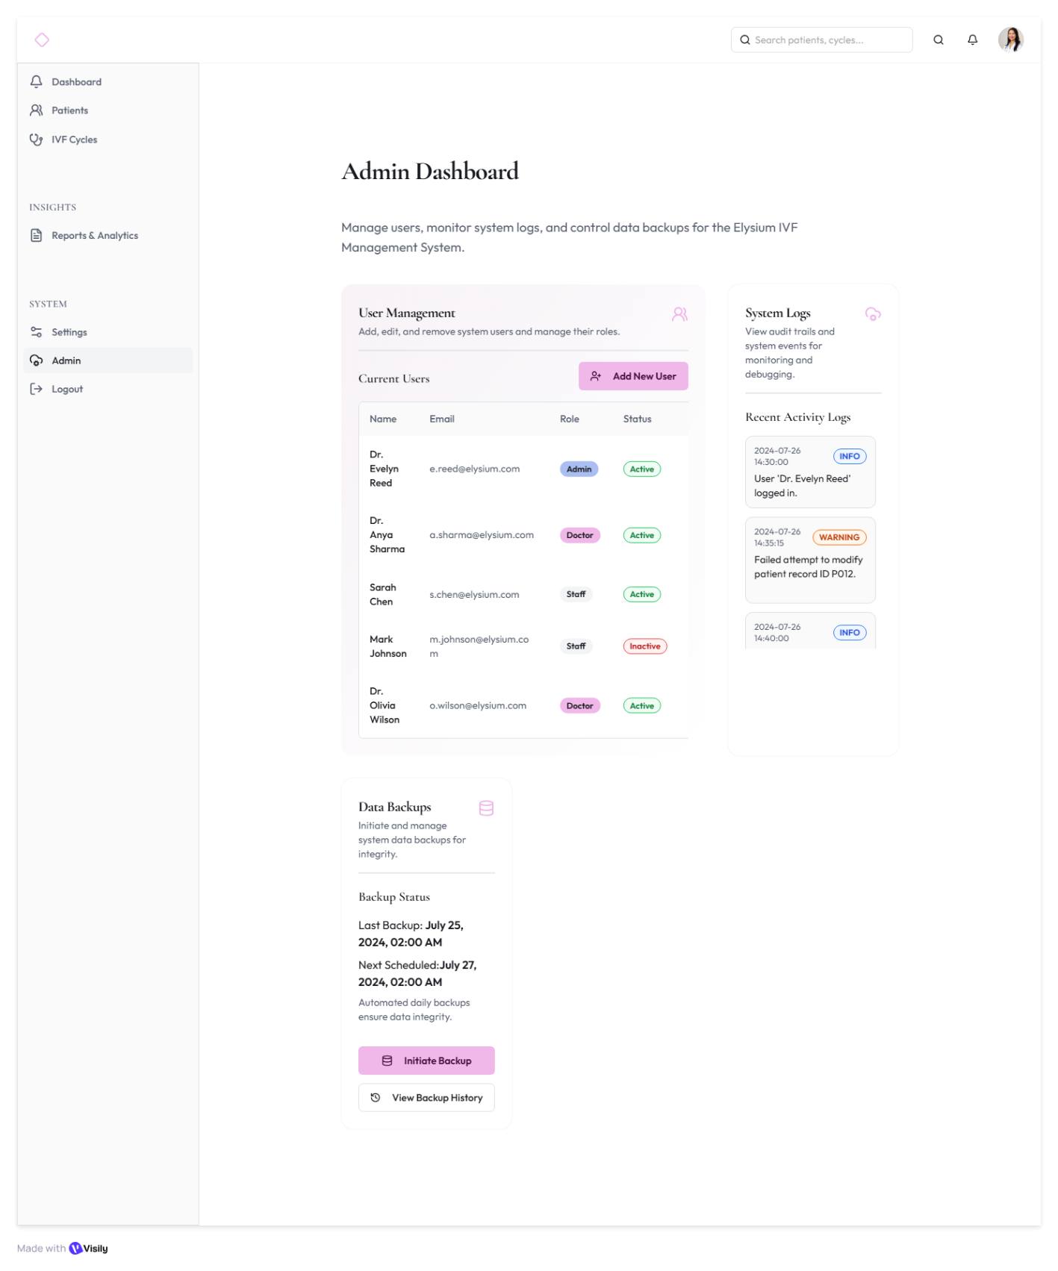

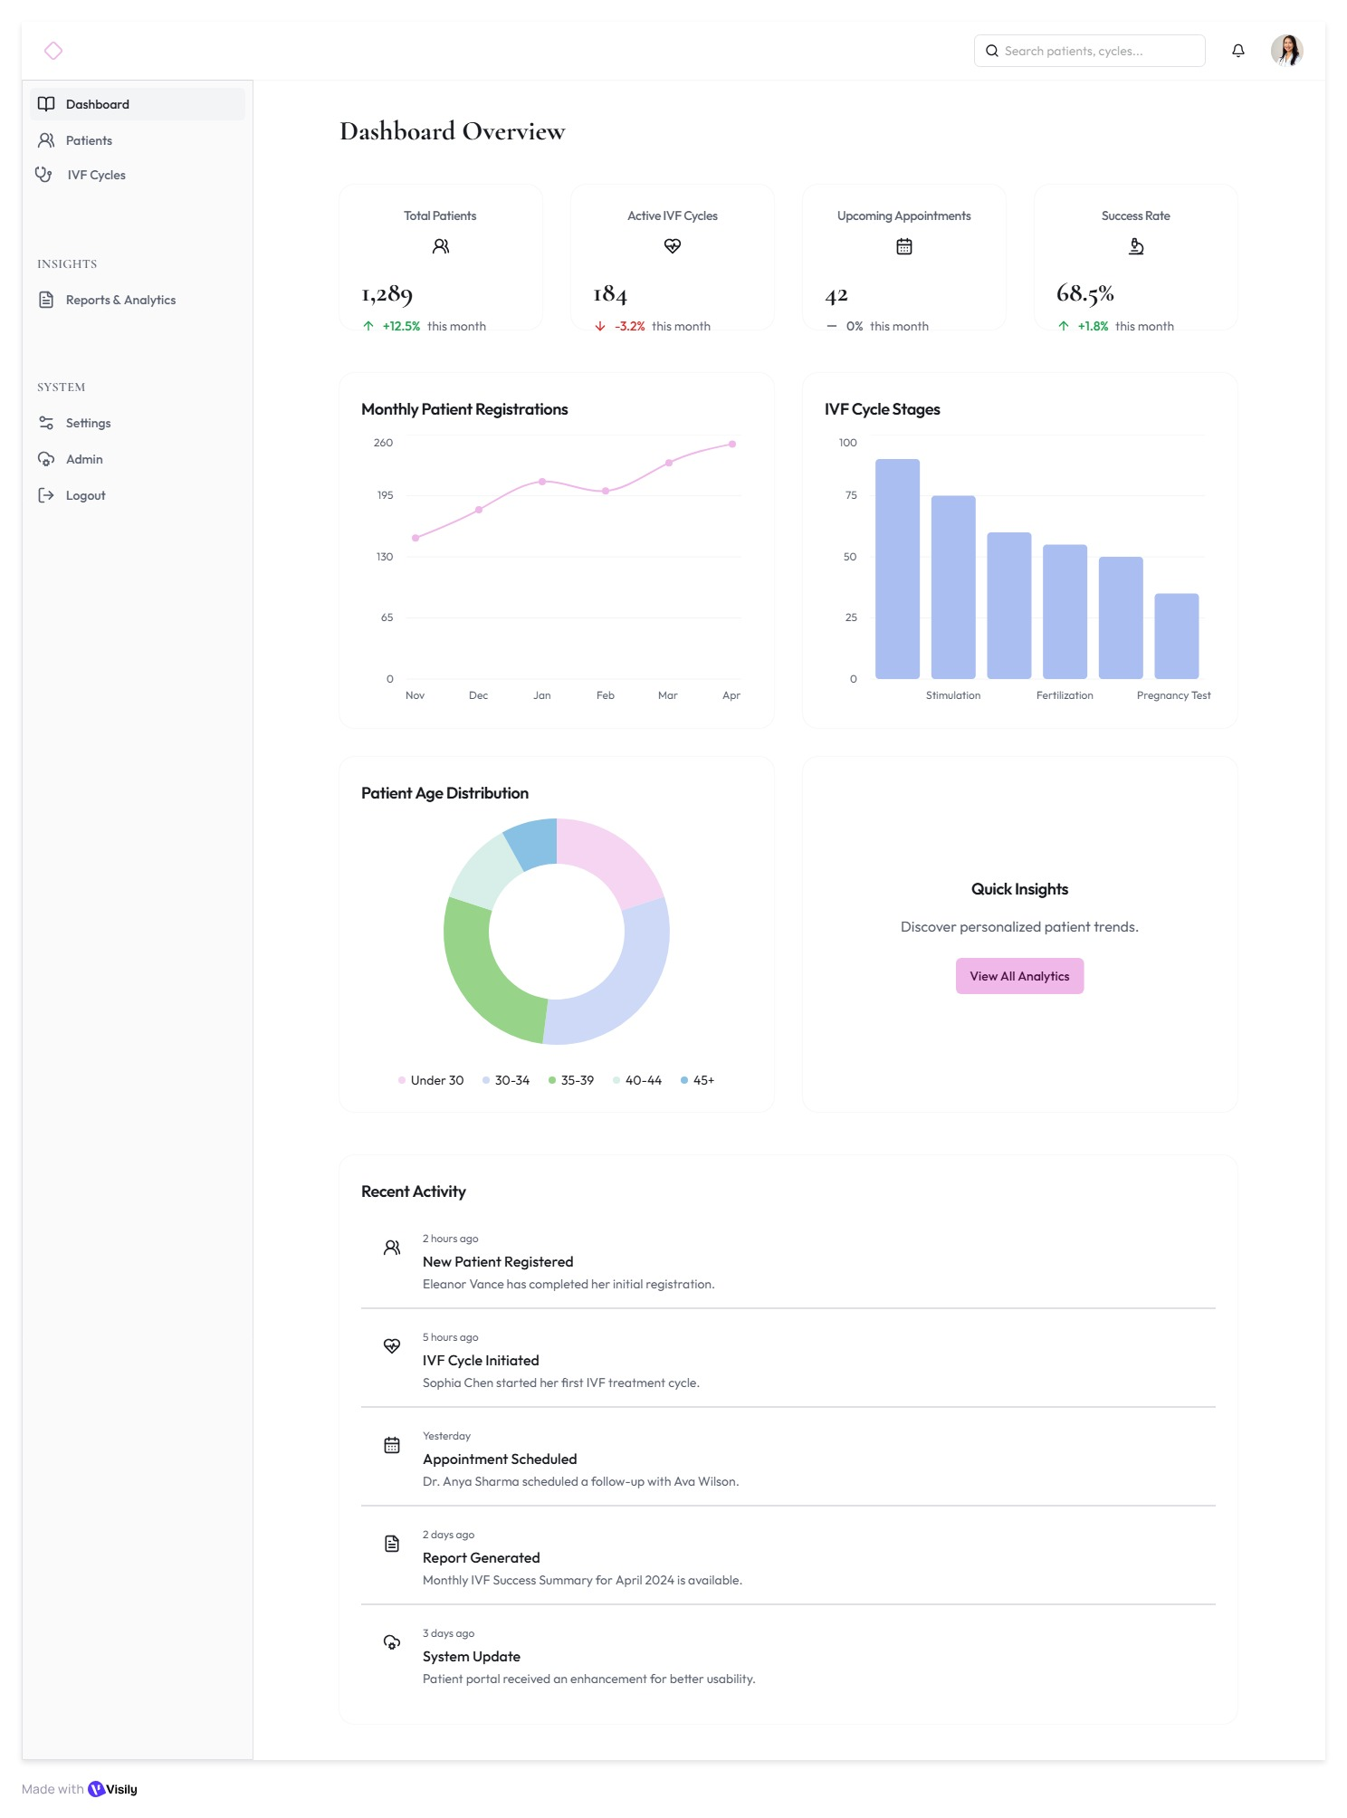

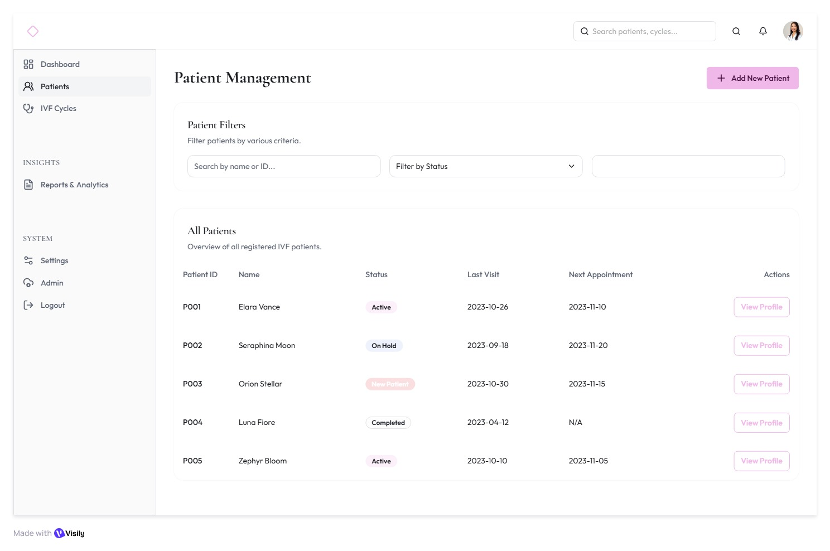
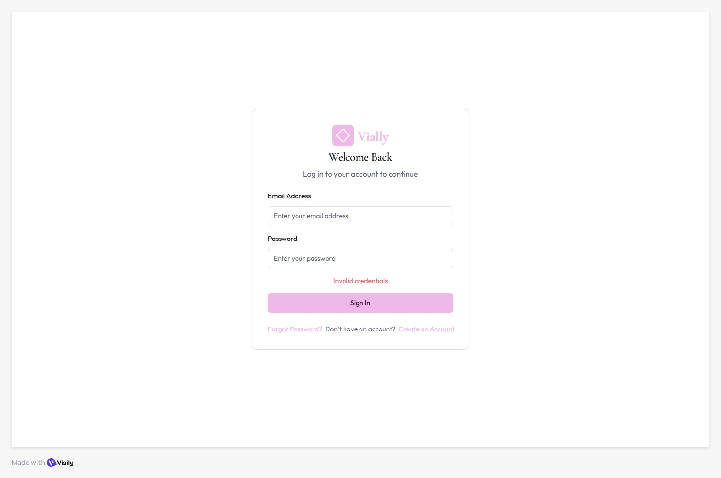
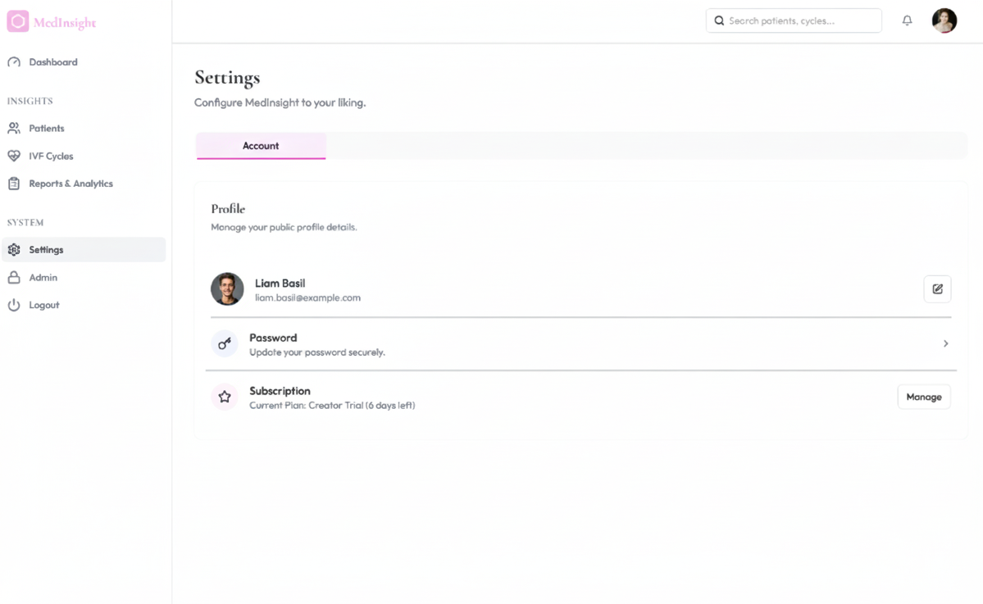

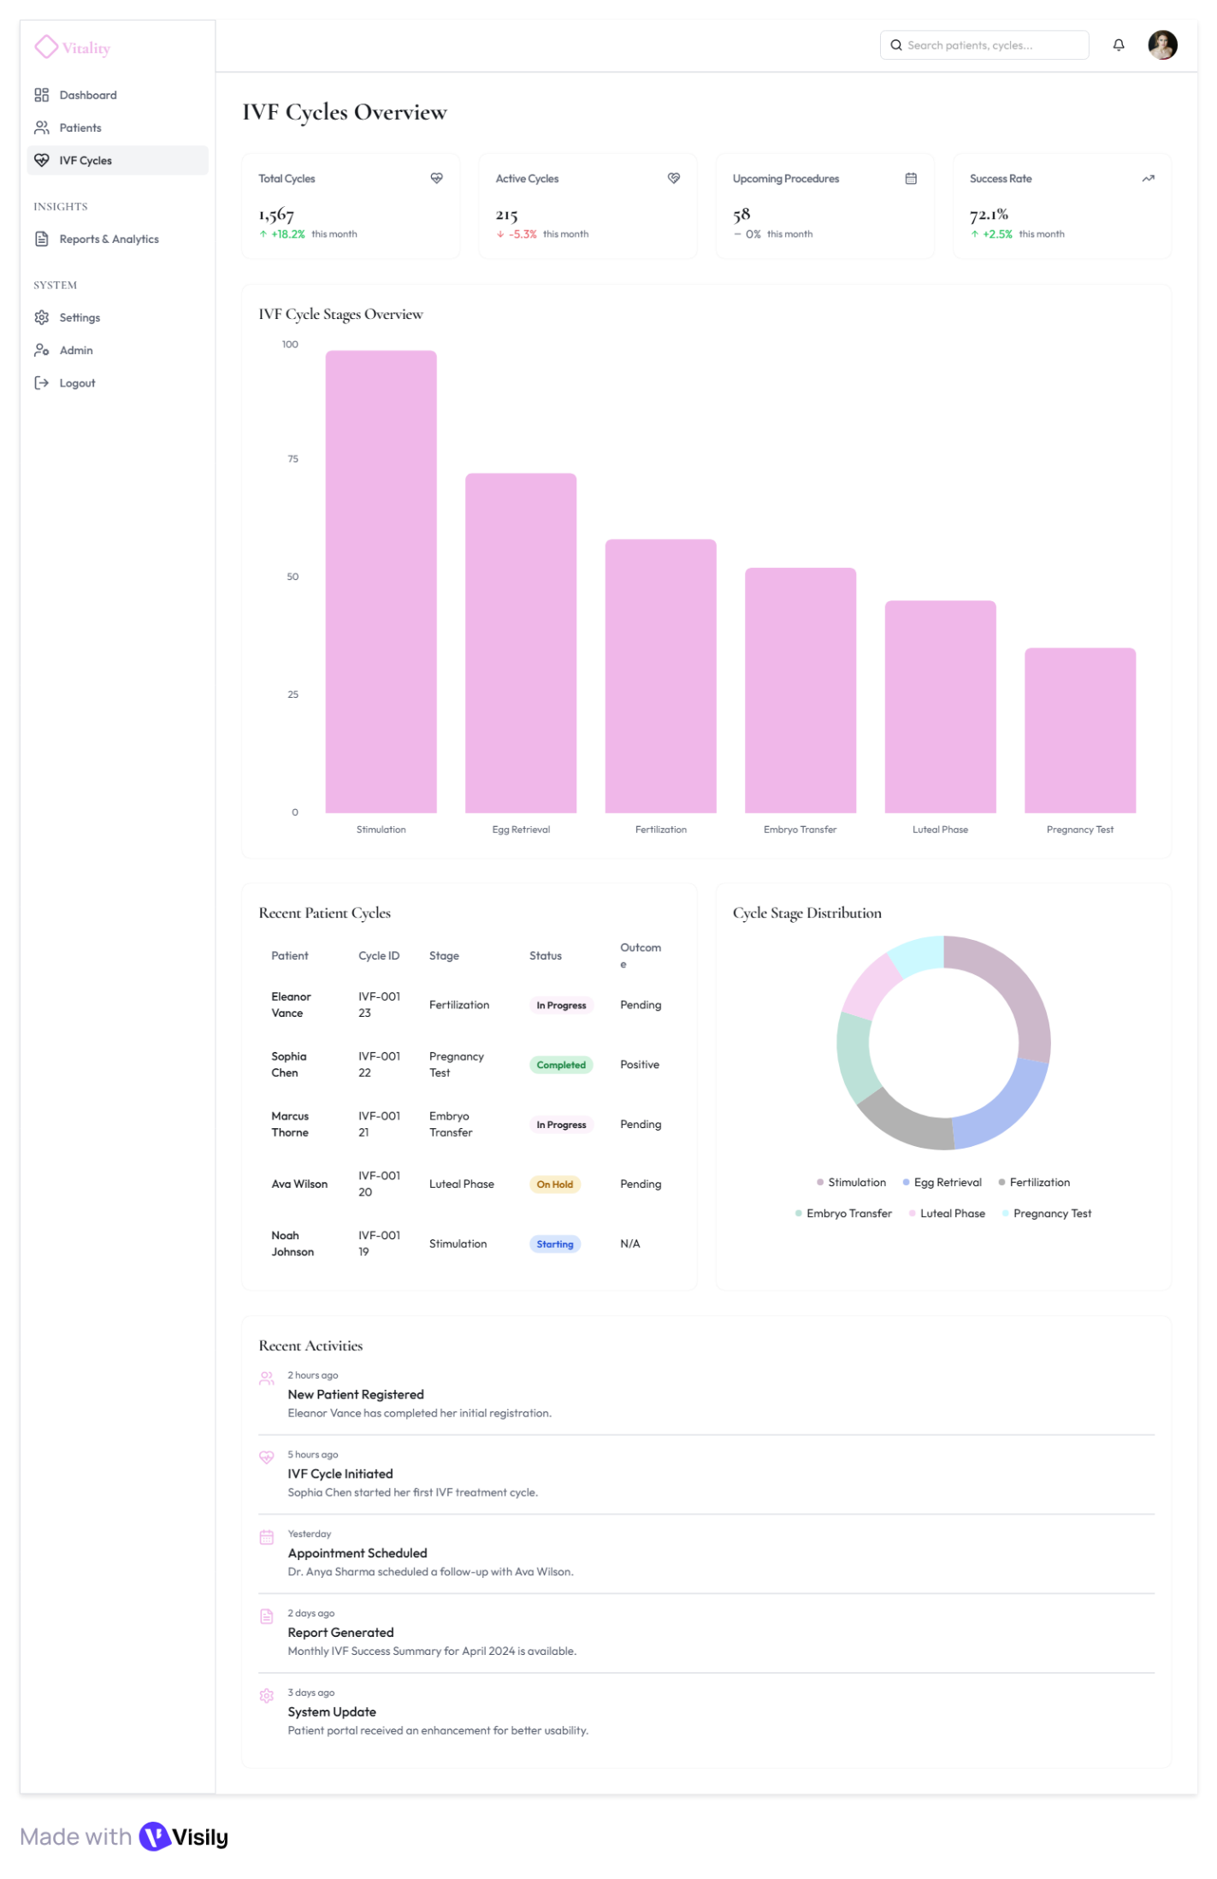

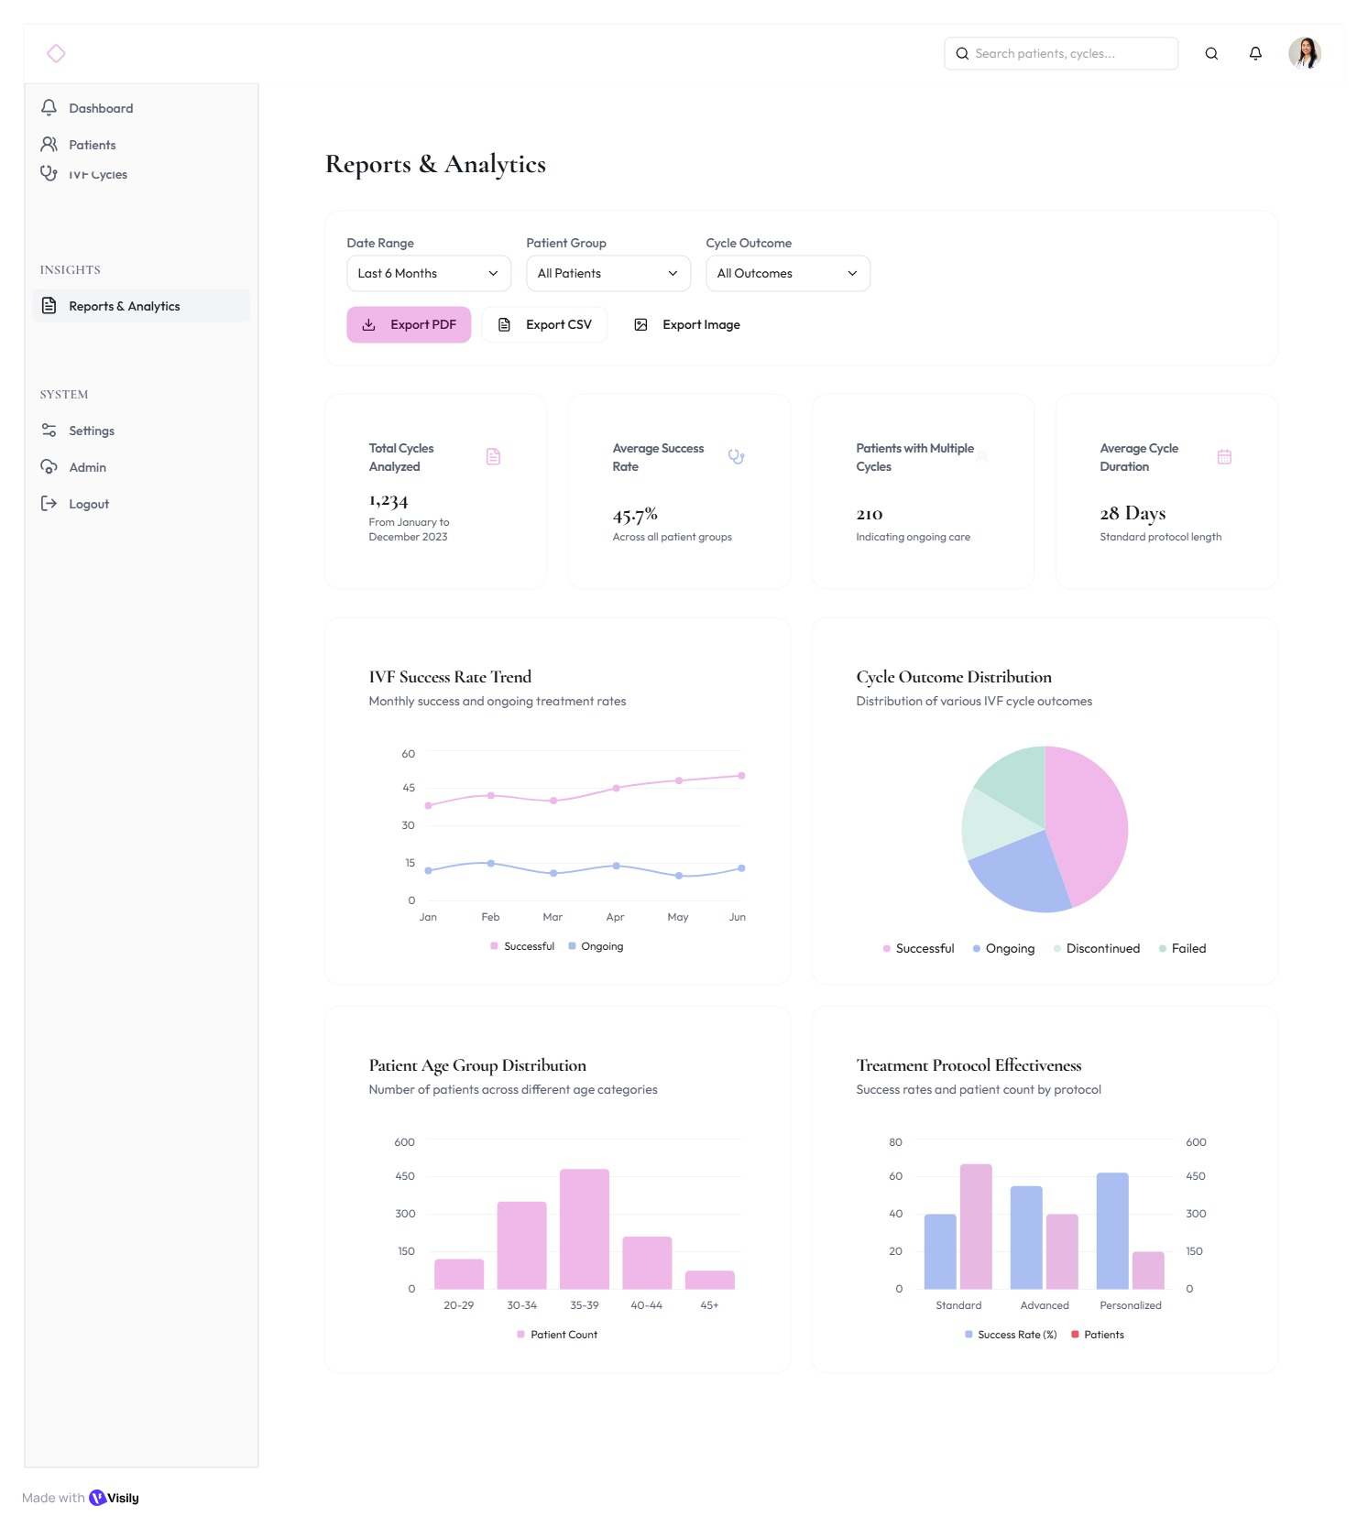

  - UI/UX Guidelines

    - Phase 1: Doctor-Only MVP Flow

1. Login / Authentication
Input: Email, Password
Validate credentials
Redirect to Doctor Dashboard
Error: Display "Invalid credentials" message
Action Links: Forgot Password? and Create an Account links are available below the Sign In button.

2. Dashboard Page
Purpose: Overview of clinic activity and insights
Top Cards:
- Total Patients
- Active IVF Cycles
- Upcoming Appointments
- Success Rate
Charts & Visuals:
- Line chart Monthly Patient Registrations
- Bar chart IVF Cycle Stages
- Donut chart Patient Age Distribution
Recent Activity Feed:
- New Patient Registered
- IVF cycle initiated
- Appointment Scheduled
- Report Generated
- System Update

3. Patients Page
Purpose: Manage all patient-related data
Interface Elements:
Patient List Table (Patient ID, Name, Status, Last Visit, Next Appointment, Actions)
- Search by name or ID text input
- Filter by Status dropdown (Status options: Active, Completed, New Patient, On Hold)
- Add New Patient opens form
Patient Profile Modal (Tabs):
- Overview
- Medical History
- IVF Cycle Details
- Notes
- Upload Reports (PDF, images)
Action Buttons:
- View Profile opens patient modal
- Edit/Upload Save Changes
Flow:
Dashboard Patients View Profile Action Button opens Patient Profile Modal (Tabs listed above) Edit/Upload Save Changes

4. IVF Cycles Page
Purpose: Track IVF cycle progress and data input
Sections:
- Recent Patient Cycles
- Cycle Stage Distribution
Charts:
- Total Cycles (linked to patient)
- Active Cycles
- Upcoming Procedures
- Bar char IVF Cycle Stages Overview
- Donut char Cycle Stage Distribution
Recent Activity Feed:
- [New Patient Registered
- IVF cycle initiated
- Appointment Scheduled
- Report Generated
- System Update
Recent Patient Cycles section
- Patient name id-stage-status - outcome

5. Reports & Analytics
Purpose: Visualize clinical performance
Filters:
- Date range
- Patient Group
- Cycle Outcome
Cards:
- Total Cycles Analyzed
- Average Success Rate
- Patients with Multiple Cycles
- Average Cycle Duration
Visuals:
- Line chart IVF Success Rate Trend
- Pie chart Cycle Outcome Distribution
- Bar chart Patient Age Group Distribution
- Bar chart Treatment Protocol Effectiveness
- Export as PDF/CSV/Image
Flow:
Dashboard Reports & Analytics Filter Export

6. Settings
Options:
- Sub-Tabs: Account
Profile Section:
- Name & Email (with Edit icon)
- Password (with Action Arrow)
- Subscription (with Manage Button)
Flow:
Dashboard Settings (Select Sub-Tab: Account, Display, Notifications, Integrations, Security, Support & Danger) Manage

7. Admin Dashboard
Purpose: Admin Dashboard - Manage users, monitor system logs, and control data backups.
Sections:
- User Management
- System Logs
- Data Backups
User management section
- User List Table columns: Name, Email, Role, Status. (This table contains all user roles: Admin, Doctor, Staff).
- Add new user opens form for dr info
System Logs:
- View audit trails and events. Contains Recent Activity Logs with timestamps, event descriptions, and tags (INFO, WARNING).
Data Backups:
- Shows Backup Status (Last Backup Date/Time, Next Scheduled Date/Time).
      - Actions include Initiate Backup and View Backup History

- System Deployment & Integration
  - Technology Stack
The Elysium IVF Management System is designed with a modular and scalable architecture to ensure smooth deployment and integration across all system phases.
    - Backend (Server Layer):
- Framework: Flask (Python) – used to build RESTful APIs for CRUD operations and data exchange between frontend and database.
- Libraries & Tools: Pandas, NumPy, SQLite3, MLflow (for model management), and Airflow (for scheduling data workflows).
- APIs: Flask REST API endpoints for patient management, IVF cycles, reports, and analytics integration.
    - Frontend (Client Layer):
- Technologies: HTML5, CSS3, JavaScript (ES6), and Bootstrap.
- Design Style: UI/UX inspired by soft pastel color palettes (blush pink, lavender, and teal) with a rounded typography (Poppins/Nunito).
- Visualization Tools: Plotly Dash and Power BI dashboards embedded for real-time analytics and reports visualization.
    - Database Layer:
- Database Engine: PostgreSQL (hosted on AWS RDS).
- Data Warehouse: AWS Redshift / Snowflake (for analytical workloads).
- Storage: AWS S3 used as a raw and staging data zone for ingestion pipelines.
- Schema Design: Star Schema – consisting of fact and dimension tables (Facment_IVF_Cycles, Dim_Patient, Dim_Hormones, Dim_Embryos, Dim_Treatt).
    - Integration & Deployment Environment:
- Cloud Platform: AWS (S3, RDS, EC2, Redshift).
- Workflow Orchestration: Apache Airflow for automated ETL and ML pipelines.
- Monitoring & Validation: Great Expectations for data quality checks and Airflow alerts for pipeline monitoring.
- Version Control & Collaboration: GitHub.
    - Deployment Approach:
- Flask backend deployed on AWS EC2 instance.
- Frontend served via Flask static routes.
- Database connected securely through AWS RDS.
- Airflow DAGs automated for data ingestion, transformation, and retraining pipelines.

  - Component Diagram
